Module 3 Challenge codes

import pandas as pd

import numpy as np

df_election = pd.read_csv(r"C:\Users\karki\Downloads\Starter_Code (4)\Starter_Code\PyPoll\Resources\election_data.csv")

display(df_election)

df_election_list = df_election['Candidate'].unique()

df_election_list

df_election_total =len(df_election.value_counts())

df_election_total

df_total_votes = df_election['Candidate'].value_counts()

df_total_votes

df_election['Candidate'].value_counts(normalize=True)

df_percent = df_election['Candidate'].value_counts(normalize=True).mul(100).round(3).astype(str) + '%'

df_percent

print('Election Results')

print('----------------------------------')

print('Total Votes:')

print(df_election_total)

print('----------------------------------')

print(df_percent)

print('----------------------------------')

print('Winner : Diana DeGette with 73.812% vote')

print('----------------------------------')

fig: Executable code for exercise 2

import pandas as pd

df_Budget = pd.read_csv(r"C:\Users\karki\Downloads\Starter_Code (4)\Starter_Code\PyBank\Resources\budget_data.csv")

df_Budget.head()

df_total_months = len(df_Budget['Date'].value_counts())

df_total_months

df_Total = df_Budget['Profit/Losses'].sum()

df_Total

df_mean = df_Budget['Profit/Losses'].mean()

df_mean.round(decimals=2)

min_least = df_Budget['Profit/Losses'].idxmin()

df_min = df_Budget.iloc[min_least]

df_min

max_index = df_Budget['Profit/Losses'].idxmax()

df_max = df_Budget.iloc[max_index]

df_max

print('Financial analysis')

print('----------------------------------')

print('Total Months :')

print(df_total_months)

print("Total Profit/Losses:")

print(df_Total)

print('Average Change: ')

print(df_mean.round(decimals=2))

print('Greatest Increase in Profits:')

print(df_max)

print('---------------------------')

print('Greatest Decrease in Profits:')

print(df_min)

Fig : Executable code for exercise 1

The screenshots for the answers to both challenges are pasted below:

Challenge 1 payroll

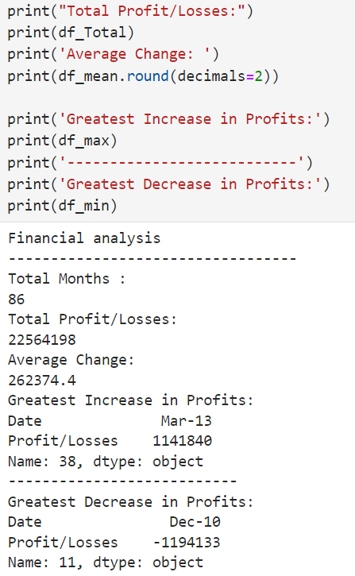

* In this exercise I have utilized various codes and functions to get the requested results.

Challenge 2 Election

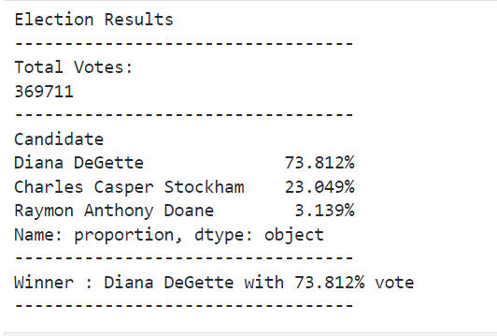

* In this exercise I have utilized various codes and functions to get the requested results.